Containerization

>> <https://www.bmc.com/blogs/aws-ecs-vs-eks/>

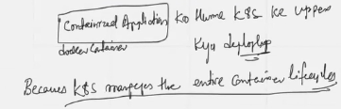

containerized application <-> docker container

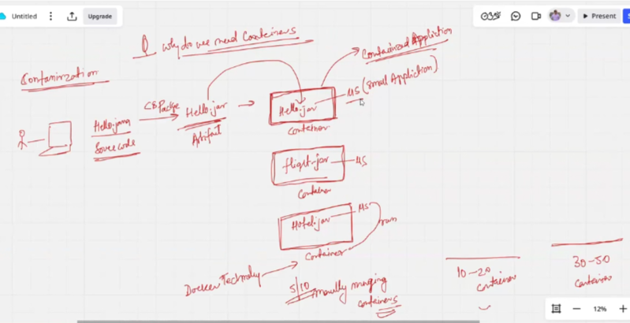

Docker

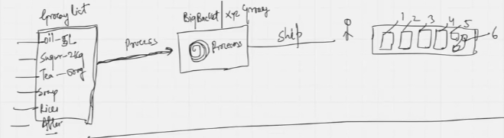

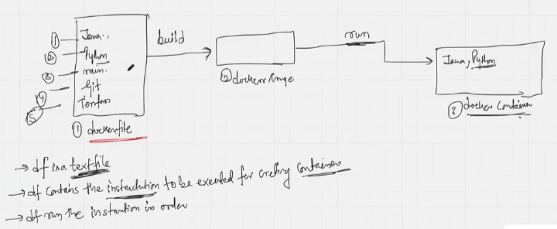

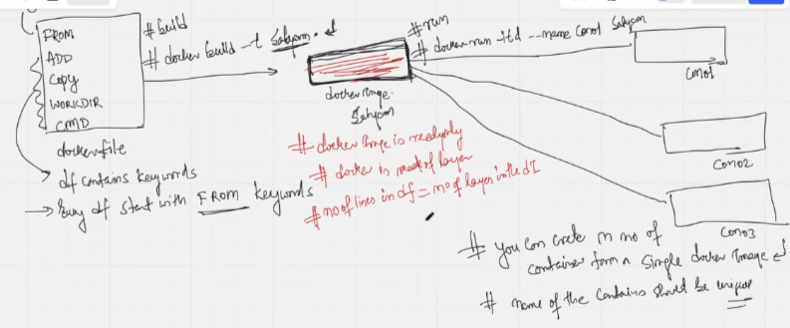

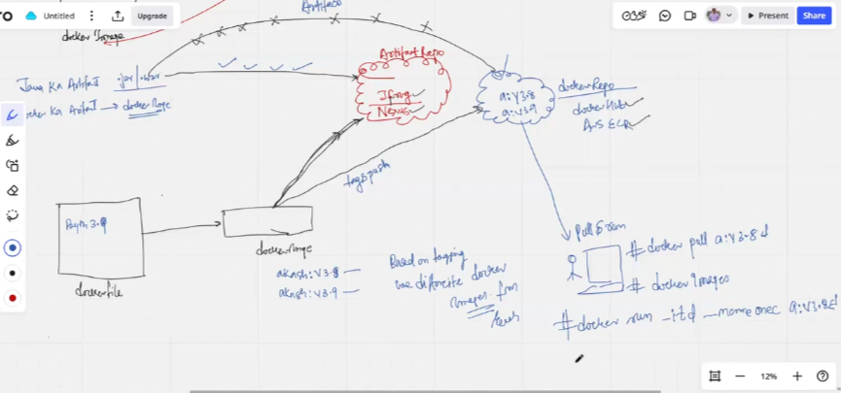

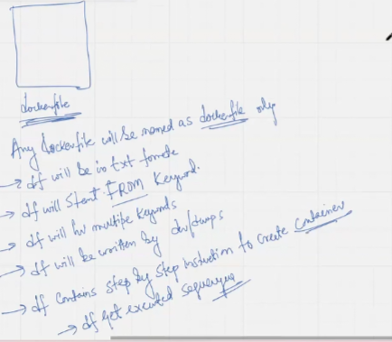

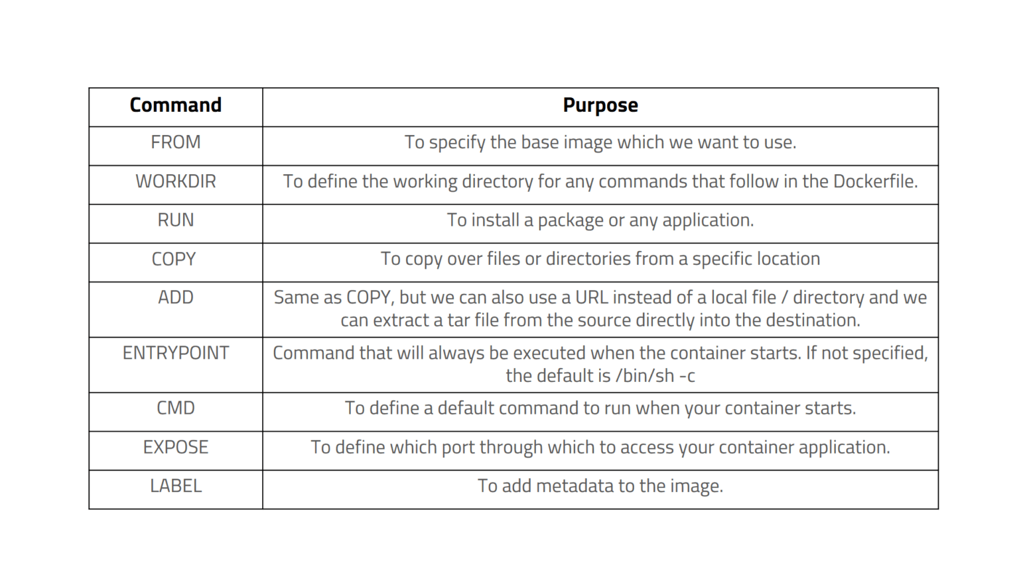

History of containers

Critically important for interviews

Laptop >> 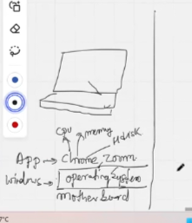 >> RISC v/s CISC

<https://youtu.be/LgtVX9SOWaw>

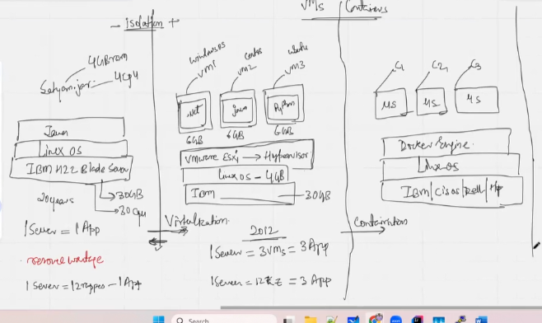

Shift since 20 yrs from 1 server to virtualization to containerization

LinuxOS+Podman >> 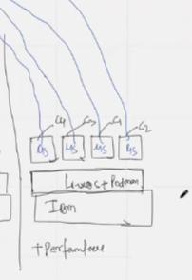 >> Performance

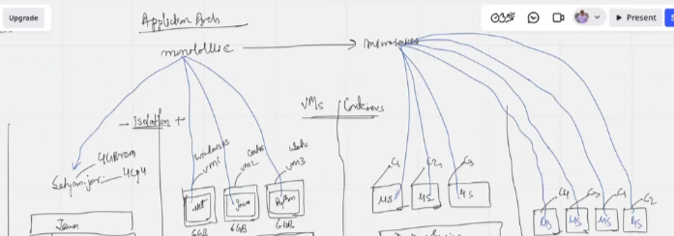

Application architecture styles

Difference between virtualization and containerization

**Virtualization**

Every Vm has its own full fledged GuestOS

VM restart 60s to 90s

Memory utilization is fully occupied even if needed is less

**Containerization**

Container=Vm-OS. Container don’t have full fledged OS

Container take 5s to restart

Memory utilization is apt. Rest memory is released for other microservices-container pair